**7**

**Learner’s Material**

**Module 4**

This instructional material was collaboratively developed and reviewed by educators from public and private schools, colleges, and/or universities. We encourage teachers and other education stakeholders to email their feedback, comments, and recommendations to the Department of Education at [action@deped.gov.ph](mailto:action@deped.gov.ph).

**We value your feedback and recommendations.**

**Department of Education**

**Republic of the Philippines**

**Mathematics – Grade 7**

**Learner’s Material**

**First Edition, 2013**

**ISBN: 978-971-9990-60-4**

**Republic Act 8293, section 176** states that: No copyright shall subsist in any work of the Government of the Philippines. However, prior approval of the government agency or office wherein the work is created shall be necessary for exploitation of such work for profit. Such agency or office may, among other things, impose as a condition the payment of royalties.

Borrowed materials (i.e., songs, stories, poems, pictures, photos, brand names, trademarks, etc.) included in this book are owned by their respective copyright holders. Every effort has been exerted to locate and seek permission to use these materials from their respective copyright owners. The publisher and authors do not represent nor claim ownership over them.

Published by the Department of Education

Secretary: Br. Armin A. Luistro FSC

Undersecretary: Yolanda S. Quijano, Ph.D.

Assistant Secretary: Elena R. Ruiz, Ph.D.

**Development Team of the Learner’s Material**

**Consultant:** Ian June L. Garces, Ph.D.

**Authors:** Elizabeth R. Aseron, Angelo D. Armas, Allan M. Canonigo, Ms. Jasmin T. Dullete, Flordeliza F. Francisco, Ph.D., Ian June L. Garces, Ph.D., Eugenia V. Guerra, Phoebe V. Guerra, Almira D. Lacsina, Rhett Anthony C. Latonio, Lambert G. Quesada, Ma. Christy R. Reyes, Rechilda P. Villame, Debbie Marie B. Verzosa, Ph.D., and Catherine P. Vistro-Yu, Ph.D.

**Editor:** Catherine P. Vistro-Yu, Ph.D.

**Reviewers**: Melvin M. Callanta, Sonia Javier, and Corazon Lomibao

**Printed in the Philippines by ____________**

**Department of Education-Instructional Materials Council Secretariat (DepEd-IMCS)**

Office Address: 2nd Floor Dorm G, PSC Complex

Meralco Avenue, Pasig City

Philippines 1600

Telefax: (02) 634-1054, 634-1072

E-mail Address: imcsetd@yahoo.com

**Table of Contents**

**Geometry**

|  |  |  |
| --- | --- | --- |
| Lesson 30: | Basic Concepts and Terms in Geometry ……………. | 184 |
| Lesson 31: | Angles …………………………………………………… | 196 |
| Lesson 32: | Basic Constructions .…………………………………… | 206 |
| Lesson 33: | Polygons ………………………………………………… | 212 |
| Lesson 34: | Triangles ………………………………………………… | 219 |
| Lesson 35: | Quadrilaterals …………………………………………... | 224 |
| Lesson 36: | Circles …………………………………………………… | 230 |

**Lesson 30: Basic Concepts and Terms in Geometry**

**About the Lesson:**

This lesson focuses on plane figures. Included in the discussion are the basic terms used in geometry such as points, lines and planes. The focus of this section is the different ways of describing and representing the basic objects used in the study of geometry.

**Objectives:**

In this lesson, the participants are expected to:

1. describe the undefined terms;
2. give examples of objects that maybe used to represent the undefined terms;
3. name the identified point(s), line(s) and plane(s) in a given figure;
4. formulate the definition of parallel lines, intersecting lines, concurrent lines, skew lines, segment, ray, and congruent segments;
5. Perform the set operations on segments and rays.

**Lesson Proper**

**A. Introduction to the Undefined Terms:**

In any mathematical system, definitions are important. Elements and objects must be defined precisely. However, there are some terms or objects that are the primitive building blocks of the system and hence cannot be defined independently of other objects. In geometry, these are **point, line**, **plane**, and **space**. There are also relationships like **between** that are not formally defined but are merely described or illustrated.

In Euclidean Geometry, the geometric terms point, line, and plane are all undefined terms and are purely mental concepts or ideas. However, we can use concrete objects around us to represent these ideas. Thus, these undefined terms can only be described.

|  |  |  |  |
| --- | --- | --- | --- |
| **Term** | **Figure** | **Description** | **Notation** |
| Point | A | A point suggests an exact location in space.  It has no dimension.  We use a capital letter to name a point. | point A |
| Line | R  V  ***m*** | A line is a set of points arranged in a row.  It is extended endlessly in both directions.  It is a one-dimensional figure.  Two points determine a line. That is, two distinct points are contained by exactly one line.  We use a lower case letter or any two points on the line to name the line. | line ***m*** or |
| Plane | P  Q  R | A plane is a set of points in an endless flat surface.  The following determine a plane: (a) three non-collinear points; (b) two intersecting lines;  (c) two parallel lines; or (d) a line and a point not on the line.  We use a lower case letter or three points on the plane to name the plane. | plane PQR or  PQR |

2. **Activity 1**

**Objects Representing the Undefined Terms**

1. These are some of the objects around us that could represent a point or line or plane. Place each object in its corresponding column in the table below.

|  |  |  |  |
| --- | --- | --- | --- |
| Blackboard | Corner of a table | intersection of a side wall and ceiling | tip of a needle |
| Laser | Electric wire | Intersection of the front wall, a side wall and ceiling | surface of a table |
| Tip of a ballpen | Wall | Edge of a table | Paper |

|  |  |  |
| --- | --- | --- |
| **Objects that could represent a point** | **Objects that could represent a line** | **Objects that could represent a plane** |
|  |  |  |

**II. Questions to Ponder:**

1. Consider the stars in the night sky. Do they represent points?
2. Consider the moon in its fullest form. Would you consider a full moon as a representation of a point?
3. A dot represents a point. How big area dot that represents a point and a dot that represents a circular region?
4. A point has no dimension. A line has a dimension. How come that a line composed of dimensionless points has a dimension?
5. A pencil is an object that represents a line. Does a pencil extend infinitely in both directions? Is a pencil a line?

**III. Exercises**

1. List down 5 other objects that could represent
   1. a point.
   2. a line.
   3. a plane.
2. Use the figure below, identify what is being asked.

A

B

C

D

E

F

G

H

I

J

***k***

M

***p***

a. Name the point(s) in the interior region of the circle.

b. Name the point(s) in the interior region of the triangle.

c. Name the line(s) in the interior region of the triangle.

d. Give other name(s) for line ***p.***

* 1. Name the plane that can be formed by the three points in the interior of the circle.
  2. Name the plane formed by line ***p*** and point I.
  3. Name the points outside the circular region.
  4. Name the points outside the region bounded by the triangle.
  5. Name the points of plane M.
  6. Give other names for plane M.

B. Recall:

a. Two points determine a line.

b. Three points not on the same line determine a plane.

c. Two intersecting lines determine a plane.

d. Two parallel lines determine a plane.

e. A line and a point not on the line determine a plane.

Given: The points A, B, C, D, E, F, G, H are corners of a box shown below:

A

B

C

D

H

G

F

E

Answer the following:

1. How many lines are possible which can be formed by these points?

(Hint: There are more than 20.) Refer to statement (a) above.

1. What are the lines that contain the point A? (Hint: There are more than 3 lines.)
2. Identify the different planes which can be formed by these points. (Hint: There are more than six. Refer to statement (d) above.
3. What are the planes that contain line DC?
4. What are the planes that intersect at line BF?

**B. Other basic geometric terms on points and lines**

The three undefined terms in Plane Geometry are **point, line,** and **plane**.

Relationships between the above objects are defined and described in the activities that follow.

|  |  |
| --- | --- |
| **Geometric Terms** | **Illustration** |
| **Collinear points** are points on the same line. |  |
| **Coplanar points/lines** are points/lines on the same plane. |  |

The following activity sheet will help us develop the definitions of the other relationships.

**Activity 2**

**Other Geometric Terms on Lines**

Refer to the figure below:

Given: The points A, B, C, D, E, F, G, H are corners of a box as shown:

A B

D C

E F

H G

# Intersecting Lines

Lines DH and DC intersect at point D. They are intersecting lines.

Lines CG and GF intersect at point G. They are also intersecting lines.

1. What other lines intersect with line DH?
2. What other lines intersect with line CG?
3. What lines intersect with EF?

**Parallel Lines**

Lines AB and DC are **parallel**.

Lines DH and CG are **parallel**.

1. What other lines are parallel to line AB?
2. What other lines are parallel to line CG?
3. What lines are parallel to line AD?

How would you describe parallel lines?

# Concurrent Lines

Lines AD, AB, and AE are concurrent at point A.

Lines GH, GF, and GC are concurrent at point G.

1. Name if possible, other lines that are concurrent at point A.
2. Name if possible, other lines that are concurrent at point G.
3. What lines are concurrent at point F?

What do you think are concurrent lines? How would you distinguish concurrent lines from intersecting lines?

# Skew Lines

Lines DH and EF are two lines which are neither intersecting nor parallel. These two lines do not lie on a plane and are called ***skew lines***. Lines AE and GF are also skew lines. The lines DH, CG, HE and GF are ***skew to*** AB.

1. What other lines are skew to DH?
2. What other lines are skew to EF?
3. What lines are skew to BF?

**Remember:**

* Two lines are **intersecting** if they have a common point.
* Three or more lines are **concurrent**if they all intersect at only one point.
* **Parallel lines** are coplanar lines that do not meet.
* **Skew lines** are lines that do not lie on the same plane.

**C.** **Subsets of Lines**

The**line segment** and the **ray** are some of the subsets of a line. A segment has two endpoints while a ray has only one endpoint and is extended endlessly in one direction. The worksheets below will help you formulate the definitions of segments and rays.

**Activity 3**

**Definition of a Line Segment**

*ABCD*

*AD* is a line segment. The points *A*, *B*, *C*, and *D* are on line segment *AD*. In notation, we write $\overline{AD}$ or simply *AD*. We can also name it as $\overline{DA}$ or *DA.*

*E F G H I J*

*FH* is a segment. The points *F*, *G*, and *H* are on line segment *FH*. The points *E*, *I*, and *J* are not on line segment *FH*. In notation, we write $\overline{FH}$. We can also name it as $\overline{HF}$ or *HF*.

*A B C D E F G H I J K L M N O P Q R S T U V*

The points *E*, *F*, *G*, and *J* are on line segment *EQ* or segment *QE*.

The points *C*, *D*,*T*, and *U* are not on line segment *EQ*.

Answer the following:

1. Name other points which are on line segment *EQ*.
2. Name other points which are not on line segment *EQ*.

Complete the following statements:

1. A line segment is part of a line that has __________.
2. Line segment *EQ* consists of the points ____________________.

**Activity 4**

The **line segment**. A ***line segment*** is part of a line that has two endpoints. We define a line segment $\overline{AB}$ as a subset of line $\overset{⃡}{AB}$ consisting of the points *A* and *B* and all the points between them. If the line to which a line segment belongs is given a scale so that it turns into the real line, then the length of the segment can be determined by getting the distance between its endpoints.

**Congruent Segments**

Given the points on the number line:

*A B C D E F G*

1 2 3 4 5 6 7 8 9 10 11

1. Determine the length of the following:

a. *AB* = _______ e. *AC*= _________

b. *DE* = _______ f. *DG* = _________

c. *BD*= _______ g. *BE* = _________

d. *DF* = _______ h. *CG* = _________

1. The following segments are congruent: *AB* and *DE*; *BD* and *DF*; *AC* and *DG*, *BE* and *CG*.
2. The following pairs of segments are not congruent: *AB* and *CF*; *BD* and *AE*; *AC* and *BF*; *BG* and *AD*.
3. Using the figure below, which segments are congruent?

*J K L M N O P Q R*

-7 -6 -5 -4 -3 -2 -1 0 1 2 3 4 5 6 7 8 9 10

Define congruent segments: Congruent segments are segments ______________.

**Remember:**

Segments are **congruent** if they have the same length.

**Activity 5**

**Definition of a Ray**

*A B C*

This is ray *AB*. We can also name it as ray *AC*.

In symbol, we write $\vec{AC}$.

The points *A*, *B*, *C* are on ray *AC*.

*X Y Z*

This is ray *ZY*. We can also name it as ray *ZX*.

In symbol, we write $\vec{ZX}$. We do NOT write it as $\overset{⃖}{XZ}$.

The points *X*, *Y*, *Z* are on ray *ZY*.

*D E F G*

This is ray *DE*. We can also name it as ray *DF* or ray *DG*.

The points *D, E, F, G* are on ray *DE*.

*Q R S T*

This is ray *TS*. We can also name it as ray *TR* or ray *TQ*.

The points *Q, R, S, T* are on ray *TS*.

*H I J K L M*

This is ray *ML*.

1. How else can you name this ray? _________

2. What are the points on ray *ML*? ________________

*N O P Q R S T U*

The points *Q, R, S, T, U* are on ray *QR*.

The points *N, O, P* are not on ray *QR*.

3. How else can you name ray *QR*?

*A B C D E F G H I J*

4. What are the points on ray *DE*?

5. What are the points not on ray *DE*?

6. How else can you name ray *DE*?

*M N O P Q R S T U V W X Y*

7. What are the points on ray *QT*?

1. What are the points on ray *PQ*?
2. What are the points on ray *XU*?

10. What are the points on ray *SP*?

In general, how do you describe the points on any ray *AC*?

_________________________________________

The **ray.** A ray is also a part of a line but has only one endpoint, and extends endlessly in one direction. We name a ray by its endpoint and one of its points. We always start on the endpoint. The figure is ray *AB* or we can also name it as ray *AC*. **It is not correct to name it as ray BA or ray CA*.*** In notation, we write or .

*A*

*C*

*B*

The points *A, B, C* are on ray *AC*.

However, referring to another ray , the point *A* is not on ray .

**Remember:**

Ray $\vec{AB}$ is a subset of the line *AB*. The points of $\vec{AB}$ are the points on segment *AB* and all the points *X* such that *B* is between *A* and *X*.

We say:

*AB* is parallel to *CD*

$\vec{AB}$ is parallel to *CD*

$\vec{AB}$ is parallel to $\overset{⃡}{CD}$

$\overset{⃡}{AB}$ is parallel to *CD*

if the lines $\overset{⃡}{AB}$ and $\overset{⃡}{CD}$ are parallel.

**D. Set operations involving line and its subsets**

Since the lines, segments and rays are all sets of points, we can perform set operations on these sets.

**Activity 6**

**The Union/Intersection of Segments and Rays**

Use the figure below to determine the part of the line being described by the union or intersection of two segments, rays, or segment and ray:

*A B C D E F*

Example: $\vec{DE}∪\vec{CF }$ is the set of all points on the ray *DE* and segment *CF*. Thus, all these points determine ray $\vec{CD}$.

$\vec{BC}∩\vec{ED}$ is the set of all points common to ray $\vec{BC}$ and ray $\vec{ED}$. The common points are the points on the segment *BE*.

Answer the following:

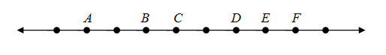

$\overline{AB}∪\overline{BE}=____________$

$\vec{DF}∪\overline{BD}=____________$

$\vec{CB}∪\overline{CE}=____________$

$\vec{DE}∪\overline{BD}=____________$

$\vec{CA}∪\vec{CD}=____________$

$\overline{BF}∩\overline{AD}=____________$

$\vec{FD}∩\overline{AB}=____________$

$\vec{FE}∩\vec{CD}=____________$

$\vec{CA}∩\vec{CE}=____________$

$\overline{BC}∩\vec{CE}=____________$

**Summary**

In this lesson, you learned about the basic terms in geometry which are point, line, plane, segment, and ray. You also learned how to perform set operations on segments and rays.

**Lesson 31: Angles**

**Prerequisite Concepts**: Basic terms and set operation on rays

**About the Lesson:**

This lesson is about angles and angle pairs, and the angles formed when two lines are cut by a transversal.

**Objectives:**

In this lesson, you are expected to:

1. Define angle,angle pair, and the different types of angles

1. Classify anglesaccording to their measures
2. Solve problems involving angles.

**Lesson Proper**

We focus the discussion on performing set operations on rays. The worksheet below will help us formulate a definition of an angle.

# Definition of Angle

1. **Activity**

**Activity 7**

**Definition of an Angle**

The following are angles:

The following are not angles:

Which of these are angles?

How would you define an angle?

An angle is ___________________________________.

An **angle** is a union of two non-collinear rays with common endpoint. The two non-collinear rays are the ***sides*** of the angle while the common endpoint is the ***vertex***.

1. **Questions to ponder:**
2. Is this an angle?

2. Why is this figure, taken as a whole, not an angle?

If no confusion will arise, an angle can be designated by its vertex. If more precision is required three letters are used to identify an angle. The middle letter is the vertex, while the other two letters are points one from each side (other than the vertex) of the angle. For example:

***A***

***B***

***C***

The angle on the left can be named angle *A* or angle *BAC*, or angle *CAB*. The mathematical notation is $∠A$, or $∠BAC$, or $∠CAB$.

An angle divides the plane containing it into two regions: the interior and the exterior of the angle.

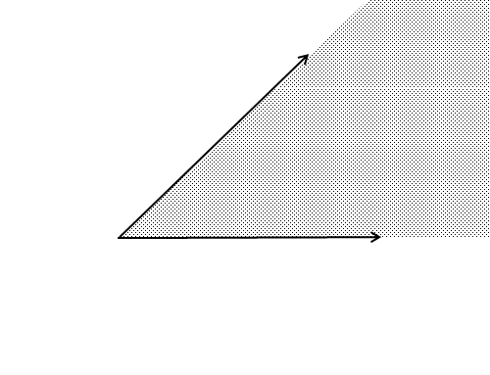

Interior of $∠A$

Exterior of $∠A$

***A***

1. **Measuring and constructing angles**
2. **Activity**

A **protractor** is an instrument used to measure angles. The unit of measure we use is the **degree**, denoted by **°**. Angle measures are between 0º and 180º. The measure of $∠A$ is denoted by m $∠A$, or simply $∠A$.

# Activity 8

# Measuring an Angle

1. Construct angles with the following measures: 90º, 60º, 30º, 120º
2. From the figure, determine the measure of each angle.

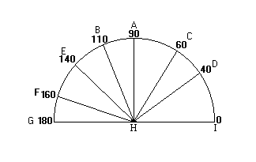

1. ∠*EHC* = ________ 6. ∠*CHB* = ________ 11. ∠*BHE* = _______

2. ∠*CHF* = ________ 7. ∠*DHG* = ________ 12. ∠*CHI* = _______

3. ∠*IHA* = ________ 8. ∠*FHI* = ________ 13. ∠*BHG* = _______

4. ∠*BHD* = ________ 9. ∠*EHF* = ________ 14. ∠*CHD* = _______

5. ∠*AHG* = ________ 10. ∠*DHI* = ________ 15. ∠*BHI* = ________

# Exercise 9

# Estimating Angle Measures

A. In the drawings below, some of the indicated measures of angles are correct and some are obviously wrong. Using estimation, state which measures are correct and which are wrong. The measures are given in degrees. **You are not expected to measure the angles.**

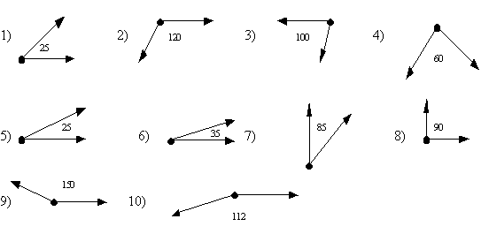

**Discussion:**

The three different types of angles are acute, right and obtuse angles. An ***acute angle*** measures more than 0º but less than 90º; a ***right angle*** measures exactly 90º while an ***obtuse angle*** measures more than 90º but less than 180º. If two lines or segments intersect so that they form a right angle, then they are ***perpendicular***. In fact, two perpendicular lines meet to form four right angles.

Note that we define angle as a union of two non-collinear rays with a common endpoint. In trigonometry, an angle is sometimes defined as the rotation of a ray about its endpoint. Here, there is a distinction between the initial position of the ray and its terminal position. This leads to the designation of the initial side and the terminal side. The measure of an angle is the amount of rotation. If the direction of the rotation is considered, negative angles might arise. This also generates additional types of angles: the zero, straight, reflex and perigon angles. A zero angle measures exactly 0º; a straight angle measures exactly 180º; a reflex angle measures more than 180o but less than 360º and a perigon angle measures exactly 360º.

1. **Question to ponder:**

If $∠M$ is an acute angle, what are the possible values of ***n***?

(3***n*** -60)o

1. **On Angle Pairs:**
2. **Definitions**

Two angles are **adjacent** if they are coplanar, have common vertex and a

common side but have no common interior points.

Two angles are **complementary** if the sum of their measures is 900.

Two angles are **supplementary** if the sum of their measures is 1800.

Two angles form a **linear pair** if they are both adjacent and supplementary.

**Vertical angles** are the opposite angles formed when two lines intersect.

Vertical angles are congruent.

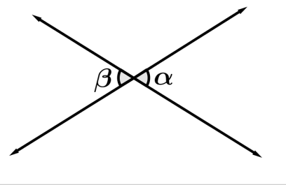

In the figure, $∠α$ and $∠β$ are vertical angles.

1. **Activity**

**Exercise 10**

**Parts of an Angle**

X

Y

Z

W

V

Use the given figure to identify the following:

1. The sides of ∠YVW ____________

2. The sides of ∠XVY ____________

3. The angle(s) adjacent to ∠ZVW ____________

4. The angle(s) adjacent to ∠ XVZ ____________

5. The angle(s) adjacent to ∠YVZ ____________

6. The side common to ∠ XVY and ∠YVZ ____________

7. The side common to ∠XVZ and∠ZVW ____________

8. The side common to ∠XVZ and∠ZVY ____________

9. The side common to ∠XVY and ∠YVW ____________

10. The common vertex. ____________

1. **Question to Ponder**

Why are the angles ∠ XVZand ∠YVZ not considered to be adjacent angles?

**Exercise 11**

1. Determine the measures of the angles marked with letters. (Note: Figures are not drawn to scale.)

1. 2. 3.

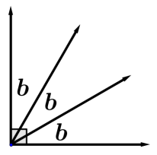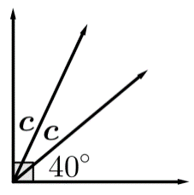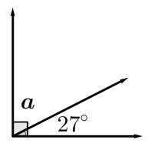

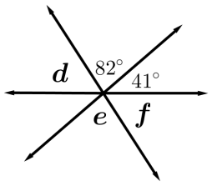

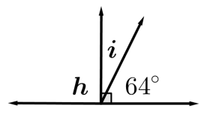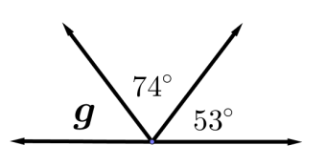 4. 5. 6.

B. Determine whether the statement is true or false. If false, explain why.

7. 20o, 30o, 40o are complementary angles.

8. 100o, 50o, 30o are supplementary angles.

Note that only pairs of angles are complementary or supplementary to each other. Hence, the angles measuring 20°, 30° and 40° are not complementary. Similarly, the angles measuring 100°, 50°, and 30° are not supplementary.

1. **Angles formed when two lines are cut by a transversal.**
2. **Discussion**

Given the lines *x* and *y* in the figure below. The line *z* is a transversal of the two lines. A **transversal**is a line that intersects two or more lines. The following angles are formed when a transversal intersects the two lines:

The **interior angles** are the four angles formed between the lines *x* and *y*. In the figure, these are $∠C$, $∠D$, $∠E$, and $∠F$.

The **exterior angles** are the four angles formed that lie outside the lines *x* and *y*. These are $∠A$, $∠B$, $∠G$, and $∠H$.

The **alternate interior angles** are two interior angles that lie on opposite sides of a transversal. The angle pairs $∠C$ and $∠F$ are alternate interior angles. So are $∠D$ and $∠E$.

The **alternate exterior angles** are two exterior angles that lie on opposite sides of the transversal. In the figure, $∠A$ and $∠H$ are alternate exterior angles, as well as $∠B$ and $∠G$.

The **corresponding angles** are two angles, one interior and the other exterior, on the same side of the transversal. The pairs of corresponding angles are $∠A$ and $∠E$, $∠B$ and $∠F$, $∠C$ and $∠G$, and $∠D$ and $∠H$.

***x***

***y***

***z***

A

E

B

C

F

G

H

D

**Activity 12**

**Angles Formed when Two Parallel Lines are Cut by a Transversal**

Draw parallel lines g and h. Draw a transversal ***j*** so that it forms an 80o angle line with ***g*** as shown. Also, draw a transversal ***k*** so that it forms a 50o angle with line ***h*** as shown.

Use your protractor to find the measures of the angles marked with letters.

A

B

C

D

E

F

G

H

I

J

K

L

M

N

80O

50O

***j***

***k***

***g***

***h***

|  |  |  |  |
| --- | --- | --- | --- |
| $$∠A=_______$$ | $$∠E=_______$$ | $$∠B=_______$$ | $$∠C=_______$$ |
| $$∠D=_______$$ | $$∠H=_______$$ | $$∠G=_______$$ | $$∠F=_______$$ |
| $$∠I=_______$$ | $$∠L=_______$$ | $$∠J=_______$$ | $$∠M=_______$$ |
| $$∠K=_______$$ |  | $$∠N=_______$$ |  |

Compare the measures of all the:

1. corresponding angles
2. alternate interior angles
3. alternate exterior angles.

What do you observe?

Complete the statements below:

When two parallel lines are cut by a transversal, then

1. The corresponding angles are ________________.
2. The alternate interior angles are _______________.

c. The alternate exterior angles are _____________.

1. **Questions to ponder:**

Use the figure below to answer the following questions:

1. If lines ***x*** and ***y*** are parallel and ***z*** is a transversal, what can you say about
2. any pair of angles that are boxed?
3. one boxed and one unboxed angle?
4. If $∠A=(20-2m)°$ and $∠D=(m-130)°$, what is the value of ***m***?

***x***

***y***

***z***

$$∠A$$

$$∠E$$

$$∠B$$

$$∠C$$

$$∠F$$

$$∠G$$

$$∠H$$

$$∠D$$

**Remember:**

When two parallel lines are cut by a transversal as shown, the boxed angles are congruent. Also, corresponding angles are congruent, alternate interior angles are congruent and alternate exterior angles are congruent. Moreover, linear pairs are supplementary, interior angles on the same side of the transversal are supplementary, and exterior angles on the same side of the transversal are supplementary.

**Exercise 13**

Determine the measures of the angles marked with letters. Lines with arrowheads are parallel. (Note: Figures are not drawn to scale.)

1. 2. 3.

n

75o

p

q

112o

j

105o

1. 5. 6.

125o

r

70o

t

83o

s

7. 8.

47o

u

v

65o

xw

109o

ww

92o

9. 10.

130o

a

b

c

33o

x

y

z

**Summary**

In this lesson, you learned about angles, constructing angles with a given measure, measuring a given angle; types of angles and angle pairs.

**Lesson 32: Basic Constructions**

**About the Lesson:**

This lesson is about geometric constructions using only a compass and straightedge.

**Objectives:**

In this lesson, you are expected to:

1. Perform basic constructions in geometry involving segments, midpoints,

angles and angle bisectors

1. Sketch an equilateral triangle accurately.

**Lesson Proper**

##### Using only the compass and straightedge, we can perform the basic constructions in geometry. We use a straightedge to construct a line, ray, or segment when two points are given. The marks indicated in the ruler may not be used for measurement. We use a compass to construct an arc (part of a circle) or a circle, given a center point and a radius length.

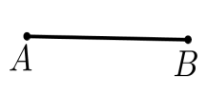**Construction 1.** To construct a segment congruent to a given segment

Given: Line segment *AB*:

Construct: Line segment *XY* congruent to *AB*.

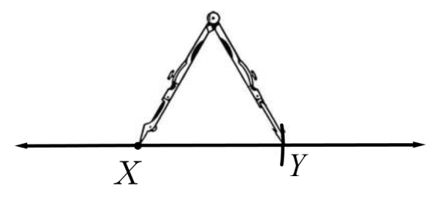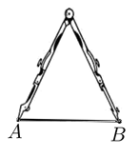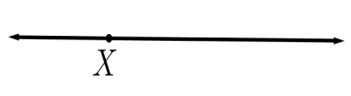

Fix compass opening to match the length of *AB.*

Use the straight edge to draw a line and indicate a point *X* on the line.

Mark on the line the point *Y* with distance *AB* from *X*.

**Construction 2.** To construct an angle congruent to a given angle.

Given: $∠A$

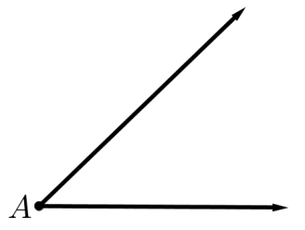

Construct: $∠W$ congruent to $∠A$.



Draw a ray with endpoint *W*.

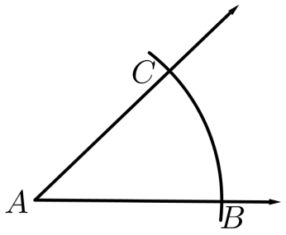

Draw a circular arc (part of a circle) with center at *A* and cutting the sides of $∠A$ at points *B* and *C*, respectively.

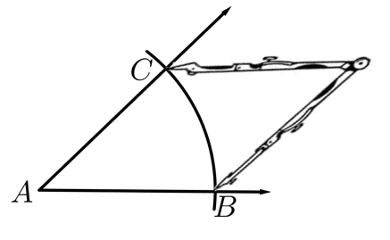

Set the compass opening to length *BC*.

Draw a similar arc using center*W* and radius *AB*, intersecting the ray at *X*.

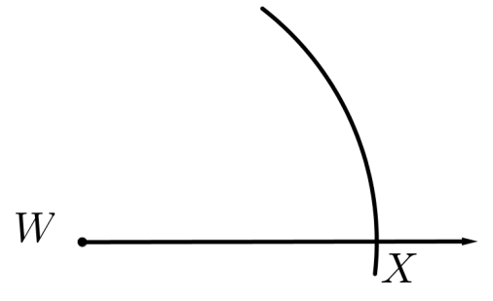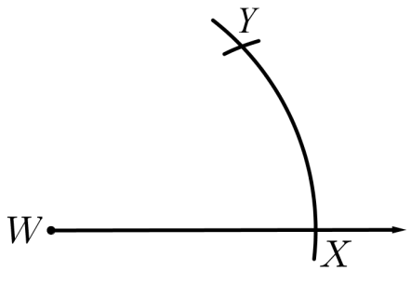

Using *X* as center and *BC* as radius, draw an arc intersecting the first arc at point *Y*.

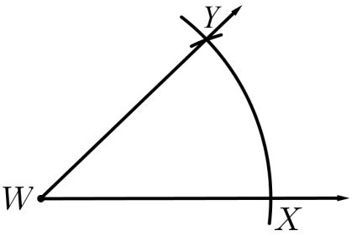

Draw ray $\vec{WY}$ to complete $∠W$ congruent to $∠A$.

**Construction 3.** To construct the bisector of a given angle.

The **bisector**of an angle is the ray through the vertex and interior of the angle which divides the angle into two angles of equal measures.

Given: $∠A$

Locate points *B* and *C* one on each side of $∠A$ so that $AB=AC$. This can be done by drawing an arc of a circle with center at *A*.

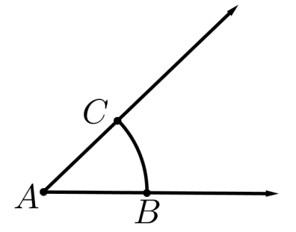

Construct: Ray $\vec{AX}$ such that *X* is in the interior of $∠BAC$ and $∠BAX=∠XAC$

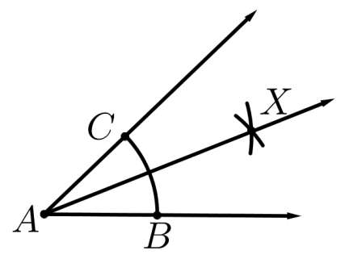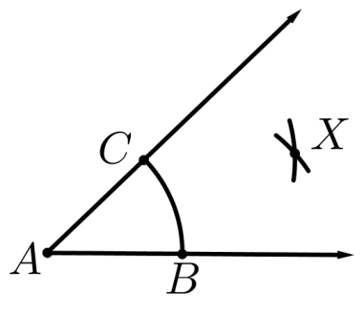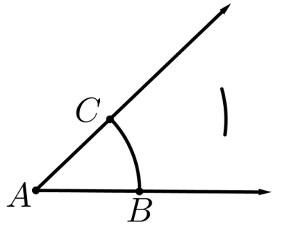

Then using *B* as center, construct an arc of the circle with the same radius *r* and intersecting the arc in the preceding step at point *X*.

Ray $\vec{AX}$ is the bisector of $∠BAC$.

Using *C* as center and any radius*r* which is more than half of *BC*, draw an arc of a circle in the interior of $∠A$.

The **midpoint** of a line segment is the point on the line segment that divides it into two equal parts. This means that the midpoint of the segment *AB* is the point *C* on *AB* such that $AC=CB$. The **perpendicular bisector** of a line segment is the line perpendicular to the line segment at its midpoint.

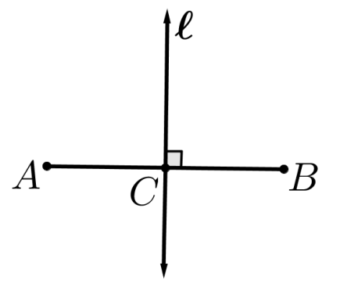

In the figure, *C* is the midpoint of *AB*. Thus, $AC=CB$.

The line $l$ is the perpendicular bisector of *AB*.

You will learn and prove in your later geometry lessons that the perpendicular bisector of a segment is exactly the set of all points **equidistant**(with the same distance) from the two endpoints of the segment. This property is the principle behind the construction we are about to do.

**Construction 5.** To construct the midpoint and perpendicular bisector of a segment.

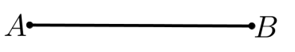

Given: Segment *AB*

Construct: The midpoint *C* of *AB* and the perpendicular bisector of *AB*.

As stated above, the idea in the construction of the perpendicular bisector is to locate two points which are equidistant from *A* and *B*. Since there is only one line passing through any two given points, the perpendicular bisector can be drawn from these two equidistant points.

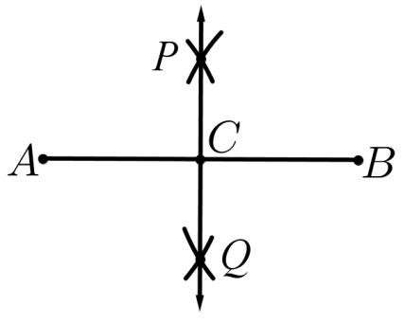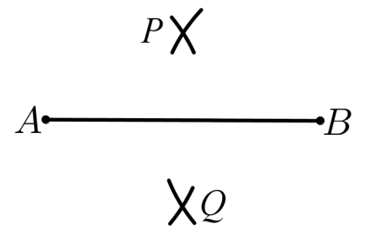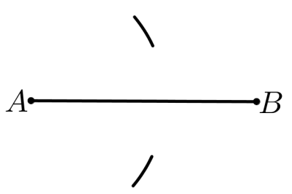

Line *PQ* is the perpendicular bisector of *AB* and the intersection of *PQ* with *AB* is the midpoint of *AB*.

Using center *A* and radius *r* which is more than half of *AB*, draw two arcs on both sides of *AB*.

Using center *B* and radius *r*, draw arcs crossing the two previously drawn arcs at points *P* and *Q*.

**Construction 6.**To constructs the perpendicular to a given line through a given point on the line.

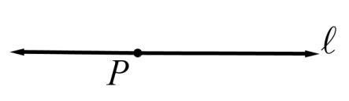

Given: Line $l$ and point *P* on $l$

Construct: Line through *P* perpendicular to $l$

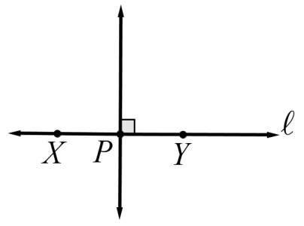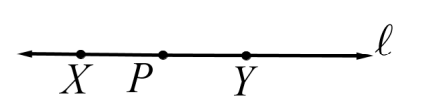

Using center *P* and any radius, locate two points, X and Y, on the circle which are on $l$.

The perpendicular bisector of *XY* is the perpendicular to $l$ that passes through *P*.

Can you see why?

**Construction 7.** To construct the perpendicular to a given line through a given point not on the line

Given: Line $l$ and point *P* which is not on $l$.

Construct: Line through *P* perpendicular to $l$.

The technique used in Construction 6 will be utilized.

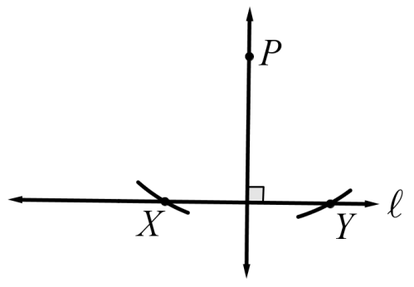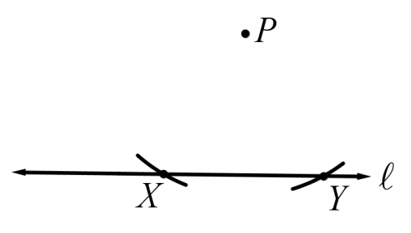

Using *P*as center draw arcs of circle with big enough radius to cross the line $l$. Mark on $l$ the two points (*X* and *Y*)crossed by the circle.

The perpendicular bisector of *XY* passes through *P* and is the line we want.

**Construction 8.** To construct a line parallel to a given line and though a point not on the given line

Given: Line $l$ and point *P* not on $l$.

Construct: Line through *P* parallel to $l$.

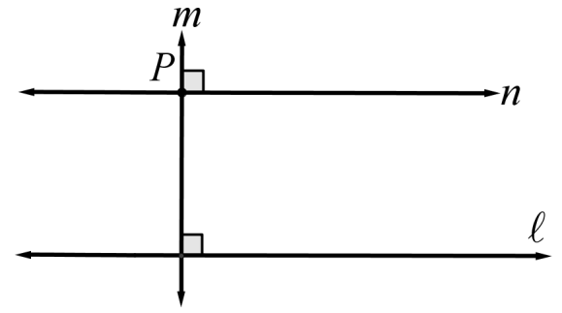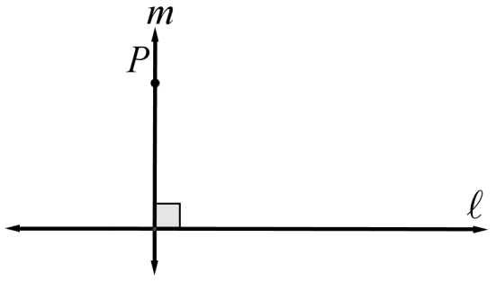

Through *P*, draw the perpendicular to *m* (Construction 6).

From *P*, draw the perpendicular *m*to $l$.

Why is *n* parallel to $l$?

**II. Exercises**

Draw ∆ABC such that AB = 6 cm, BC = 8 cm and AC = 7 cm long. Use a ruler for this.

Do the following constructions using $ΔABC$.

1. Bisect the side BC.
2. Bisect the interior ∠B.
3. Construct the altitude from vertex C. (The perpendicular from *C* to $\overset{⃡}{AB}$.)
4. Construct a line through B which is parallel to side AC.
5. Construct an equilateral triangle PQR so that PR and the altitude from vertex C have equal lengths.
6. Congruent angle construction can be used to do the parallel line construction (Construction 8) instead of perpendicular construction. How can this be done? What result are we applying in the parallel line construction?

**V. Summary**

In this lesson, basic geometric constructions were discussed.

**Lesson 33: Polygons Time: 2 hours**

**Prerequisite Concepts:** Basic geometric terms

**About the Lesson:**

This lesson is about polygons. Included in the discussion are its parts,

classifications, and properties involving the sum of the measures of the interior and exterior angles of a given polygon.

**Objectives:**

In this lesson; you are expected to:

1. Define a polygon.

2. Illustrate the different parts of a polygon.

1. State the different classifications of a polygon.
2. Determine the sum of the measures of the interior and exterior angles of a

convex polygon.

**I. Lesson Proper**

We first define the term polygon. The worksheet below will help us formulate a definition of a polygon.

**Activity 15**

**Definition of a Polygon**

The following are polygons:

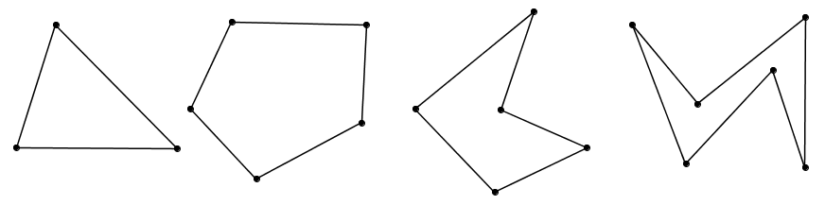

The following are not polygons:

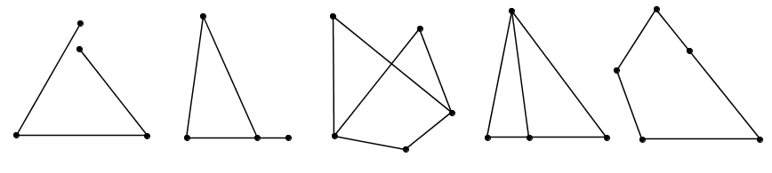

Which of these are polygons?

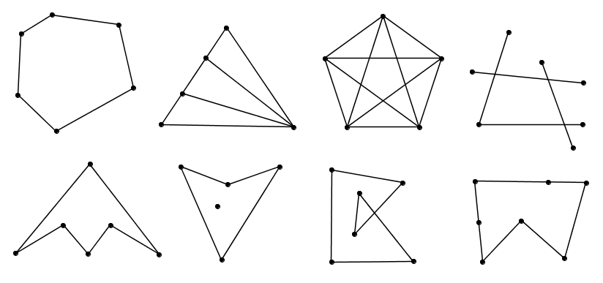

What is then a polygon?

1. **Definition, Parts, and Classification of a Polygon**

Use the internet to learn where the word “polygon” comes from.

The word “polygon” comes from the Greek words “poly**”**, which means “many” and “gon” which means “angles.”

A **polygon** is a union of non-collinear segments, **the sides**, on a plane that meet at their endpoints, **the vertices**, so that each endpoint (vertex) is contained by exactly two segments (sides).

Go back to Activity 15 to verify the definition of a polygon.

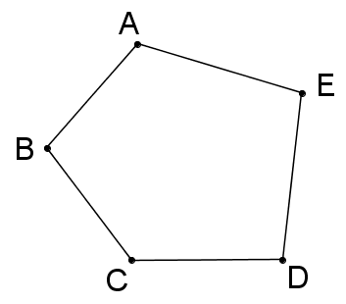

Polygons are named by writing their consecutive vertices in order, such as ABCDE or AEDCB or CDEAB or CBAED for the figure on the right.

A polygon separates a plane into three sets of points: the polygon itself, points in the interior (inside) of the polygon, and points in the exterior (outside) of the polygon.

Consider the following sets of polygons:

**Set A**

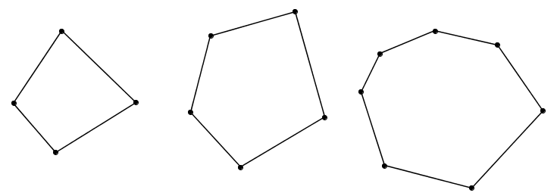



**Set B**

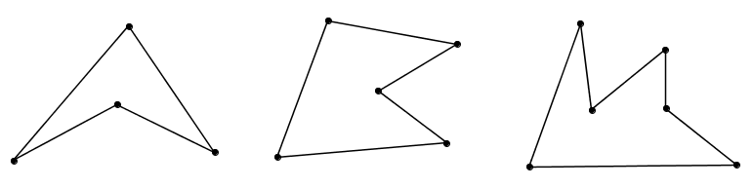

Can you state a difference between the polygons in Set A and in Set B?

Polygons in Set A are called convex, while the polygons in Set B are non-convex. A polygon is said to be **convex** if the lines containing the sides of the polygon do not cross the interior of the polygon.

There are two types of angles associated with a convex polygon: exterior angle and interior angle. **An exterior angle** of a convex polygon is an angle that is both supplement and adjacent to one of its interior angles.

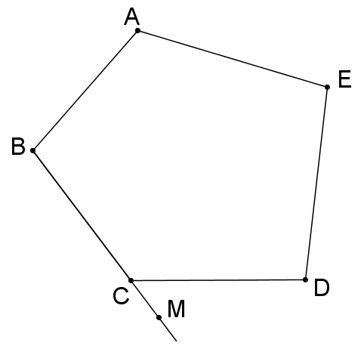

In the convex polygon ABCDE, ∠A, ∠B, ∠BCD, ∠D, and ∠E are the interior angles, while ∠MCD is an exterior angle.

**Consecutive vertices** are vertices on the same side of the polygon.

**Consecutive sides** are sides that have a common vertex. A **diagonal** is a segment joining non-consecutive vertices.

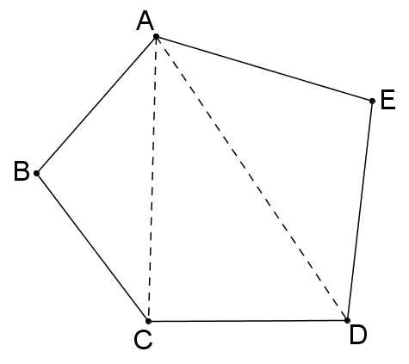

In the polygon ABCDE, some consecutive vertices are A and B, B and C.

Some consecutive sides are and ; and 

Some diagonals are and .

The different types of polygons in terms of congruency of parts are equilateral, equiangular and regular. A polygon is **equilateral** if all its sides are equal; **equiangular** if all its angles are equal; and **regular** if it is both equilateral and equiangular.

Polygons are named according to the number of sides.

|  |  |  |  |
| --- | --- | --- | --- |
| **Name of Polygon** | **Number of Sides** | **Name of Polygon** | **Number of sides** |
| Triangle | 3 | Octagon | 8 |
| Quadrilateral | 4 | Nonagon | 9 |
| Pentagon | 5 | Decagon | 10 |
| Hexagon | 6 | Undecagon | 11 |
| Heptagon | 7 | Dodecagon | 12 |
|  |  |  |  |

1. **Questions to Ponder:**

1. Can two segments form a polygon? If yes, draw the figure. If no, explain why.

2. What is the minimum number of non-collinear segments needed to satisfy the definition of polygon above?

3. Why are the following figures not considered as polygons?

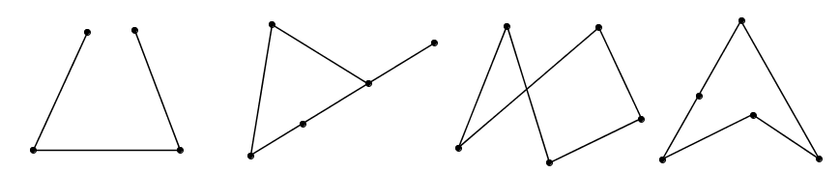

1. **Properties of a Polygon**

**Activity 16**

**Number of Vertices and Interior Angles of a Polygon**

Materials needed: match sticks, paste or glue, paper

Consider each piece of matchstick as the side of a polygon.

(Recall: A polygon is ___________________________.)

Procedure:

1) Using three pieces of matchsticks form a polygon. Paste it on a piece of paper.

1. How many sides does it have?
2. How many vertices does it have?
3. How many interior angles does it have?

2) Using four pieces of match sticks form a polygon. Paste it on a piece of paper.

a) How many sides does it have?

1. How many vertices does it have?
2. How many interior angles does it have?

3) Using five pieces of matchsticks form a polygon. Paste it on a piece of paper.

1. How many sides does it have?
2. How many vertices does it have?
3. How many interior angles does it have?

4) Using six pieces of matchsticks form a polygon. Paste it on a piece of paper.

1. How many sides does it have?
2. How many vertices does it have?
3. How many interior angles does it have?

Were you able to observe a pattern?

Complete the sentence below:

**A polygon with n sides has ___ number of vertices and ______ number of interior angles.**

**Activity 17**

**Types of Polygon**

Recall:

A polygon is ________________________________________.

A polygon is equilateral is _____________________________.

A polygon is equiangular if ____________________________.

A polygon is regular if ________________________________.

1. Determine if a figure can be constructed using the given condition. If yes, sketch a figure. If no, explain why it cannot be constructed.

1. A triangle which is equilateral but not equiangular.
2. A triangle which is equiangular but not equilateral
3. A triangle which is regular
4. A quadrilateral which is equilateral but not equiangular.
5. A quadrilateral which is equiangular but not equilateral
6. A quadrilateral which is regular.

2. In general,

1. Do all equilateral polygons equiangular? If no, give a counterexample.
2. Do all equiangular polygons equilateral? If no, give a counterexample.
3. Do all regular polygons equilateral? If no, give a counterexample.
4. Do all regular polygons equiangular? If no, give a counterexample.
5. Do all equilateral triangles equiangular?
6. Do all equiangular triangles equilateral?

**Activity 18**

**Sum of the Interior Angles of a Convex Polygon**

Materials needed: pencil, paper, protractor

Procedures:

1. Draw a triangle. Using a protractor, determine the measure of its interior angles and determine the sum of the interior angles.
2. Draw a quadrilateral. Then fix a vertex and draw diagonals from this vertex. Then answer the following:
   1. How many diagonals are drawn from the fixed vertex?
   2. How many triangles are formed by this/these diagonal(s)?
   3. Without actually measuring, can you determine the sum of the interior angles of a quadrilateral?
3. Draw a pentagon. Then fix a vertex and draw diagonals from this vertex. Then answer the following:
   1. How many diagonals are drawn from the fixed vertex?
   2. How many triangles are formed by this/these diagonal(s)?
   3. Without actually measuring, can you determine the sum of the interior angles of a pentagon?
4. Continue this with a hexagon and heptagon.
5. Search for a pattern and complete the table below:

|  |  |  |  |
| --- | --- | --- | --- |
| **No. of sides** | **No. of diagonals from a fixed vertex** | **No. of triangles formed by the diagonals drawn from a fixed vertex** | **Sum of the interior angles** |
| 3 |  |  |  |
| 4 |  |  |  |
| 5 |  |  |  |
| 6 |  |  |  |
| 7 |  |  |  |
| 8 |  |  |  |
| 9 |  |  |  |
| 10 |  |  |  |
| n |  |  |  |

6. Complete this: The sum of the interior angles of a polygon with n sides is ______.

**Activity 19**

**The Sum of the Exterior Angles of a Convex Polygon**

1. Given ΔABC with the exterior angle on each vertex as shown:

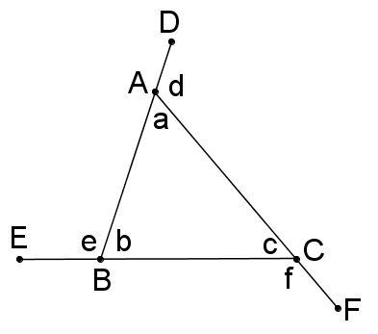

Let the interior angles at A, B, C measure a, b, c respectively while the exterior angles measure d, e, f.

Determine the following sum of angles:

a + d = _________

b + e = _________

c + f = _________

(a + d) + (b + e) + (c + f) = _________

(a + b+ c) + (d + e + f) = _________

a + b + c = _________

d + e + f = _________

2. Given the ABCD and the exterior angle at each vertex as shown:

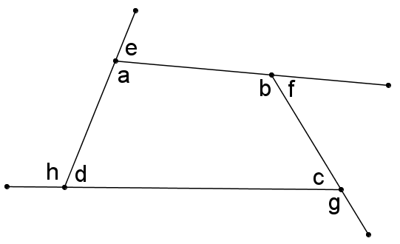

Determine the following sum:

a + e = ________

b + f = _________

c + g = _________

d + h = _________

(a + e) + (b + f) + (c + g) + (d + h) = _________

(a + b+ c + d) + (e + f + g + h) = _________

a + b + c + d = _________

e + f + g + h = _________

The sum of the exterior angles of a convex quadrilateral is ______________.

3. Do the same thing with convex pentagon, hexagon and heptagon. Then complete the following:

The sum of the exterior angles of a convex pentagon is ___________.

The sum of the exterior angles of a convex hexagon is ___________.

The sum of the exterior angles of a convex heptagon is ___________.

4. What conclusion can you formulate about the sum of the exterior angles of a convex polygon?

1. **Exercise 20**
2. For each regular polygon, determine the measure of an exterior angle.
   1. quadrilateral b. hexagon c. nonagon
3. Determine the sum of the interior angles of the following convex polygons:
   1. pentagon b. heptagon c. octagon
4. Each exterior angle of a regular polygon measures 20o. Determine the sum of its interior angles.

**Summary:**

In this lesson we learned about polygon, its parts and the different classifications of a polygon. We also performed some activities that helped us determine the sum of the interior and exterior angles of a convex polygon.

**Lesson 34: Triangles**

**Prerequisite Concepts:** Polygons

**About the Lesson:**

This lesson is about triangles, its classifications and properties.

**Objective:**

In this lesson, you are expected to:

1. Define and illustrate the different terms associated with a triangle.

2. Classify triangles according to their angles and according to their sides. .

3. Derive relationships among sides and angles of a triangle.

1. **Lesson Proper**

**A. Terms associated with a Triangle**

Given ∆ABC, its parts are the three vertices A, B, C; the three sides , and and the three interior angles ∠A, ∠B and ∠C.

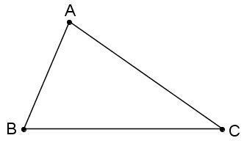

We discuss other terms associated with ∆ABC.

**Exterior angle** – an angle that is adjacent and supplement to one of the interior angles of a triangle.

**Remote interior angles of an exterior angle** – Given an exterior angle of a triangle, the two remote interior angles of this exterior angle are the interior angles of the triangle that are not adjacent to the given exterior angle.

**Angle bisector** – This is a segment, a ray or a line that bisects an interior angle.

**Altitude** – This is a segment from a vertex that is perpendicular to the line containing the opposite side.

**Median** – This is a segment joining a vertex and the midpoint of the opposite side.

**Perpendicular bisector of a side** – Given a side of a triangle, a perpendicular bisector is a segment or a line that is perpendicular to the given side and passes through the midpoint of the given side.

**Exercise 21**

**Parts of a Triangle**

Given ΔABE with AC ⊥BE and BD = DE, identify the following parts of the triangle.

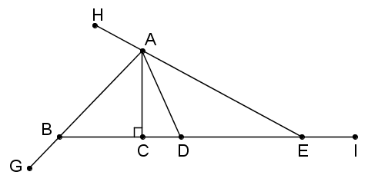

1. vertices ______________
2. sides ______________
3. interior angles ______________
4. exterior angles ______________
5. the remote interior angles of ∠ AEI ______________
6. the remote interior angles of ∠EBG ______________
7. altitude ______________
8. median ______________

**B. The lengths of the sides of a triangle**

**Activity 22**

**Lengths of Sides of a Triangle**

**Materials Needed**: coconut midribs or barbecue sticks, scissors, ruler

**Procedure:**

1. Cut pieces of midribs with the indicated measures. There are three pieces in each set.

2. With each set of midribs, try to form a triangle. Complete the table below:

|  |  |
| --- | --- |
| **Lengths of midribs (in cm)** | **Do they form a triangle or not?** |
| 3, 3, 7 |  |
| 3, 3, 5 |  |
| 4, 6, 10 |  |
| 4, 6, 9 |  |
| 5, 5, 10 |  |
| 5, 5, 8 |  |
| 6, 7, 11 |  |
| 6, 7, 9 |  |
| 4, 7, 12 |  |
| 4, 7, 10 |  |

3. For each set of lengths, add the two shortest lengths. Then compare the sum with the longest length.

What pattern did you observe?

**C. Classification of Triangles**

Triangles can be classified according to their interior angles or according to the number of congruent sides.

According to the interior angles:

**Acute triangle** is a triangle with three acute interior angles.

**Right triangle** is a triangle with one right angle.

**Obtuse triangle** is a triangle with one obtuse angle.

According to the number of congruent sides:

**Scalene triangle** is a triangle with no two sides congruent.

**Isosceles triangle** is a triangle with two congruent sides.

**Equilateral triangle** is a triangle with three congruent sides.

In an isosceles triangle, the angles opposite the congruent sides are also congruent. Meanwhile, in an equilateral triangle, all angles are congruent.

**D. Some Properties of a Triangle**

**Activity 23**

**Pythagorean Triples**

1. In a graphing paper, sketch the right triangles with the specified lengths (in cm) of legs. Then measure the hypotenuse. Let x and y be the legs and let z be the hypotenuse of the triangle.
2. Complete the first table.

|  |  |  |  |  |  |  |
| --- | --- | --- | --- | --- | --- | --- |
| Leg (x) | Leg (y) | Hypotenuse (z) |  | Leg (x) | Leg (y) | Hypotenuse (z) |
| 3 | 4 |  |  | 10 | 24 |  |
| 6 | 8 |  |  | 8 | 15 |  |
| 9 | 12 |  |  | 20 | 21 |  |
| 5 | 12 |  |  | 15 | 20 |  |

1. Compute for x2 , y2 , and z2 , and x2 + y2 and complete the second table.

|  |  |  |  |  |  |  |  |  |
| --- | --- | --- | --- | --- | --- | --- | --- | --- |
| x2 | y2 | z2 | x2 + y2 |  | x2 | y2 | z2 | x2 + y2 |
|  |  |  |  |  |  |  |  |  |
|  |  |  |  |  |  |  |  |  |
|  |  |  |  |  |  |  |  |  |
|  |  |  |  |  |  |  |  |  |

1. Compare the values of x2 + y2 with z2. What did you observe?
2. Formulate your conjecture about the lengths of the sides of a right triangle.

**II. Exercise 24**

1. True or False
2. A triangle can have exactly one acute angle.
3. A triangle can have two right angles.
4. A triangle can have two obtuse interior angles.
5. A right triangle can be an isosceles triangle.
6. An isosceles triangle can have an obtuse interior angle.
7. An acute triangle can be an isosceles triangle.
8. An obtuse triangle can be an scalene triangle.
9. An acute triangle can be an scalene triangle.
10. A right triangle can be an equilateral triangle.
11. An obtuse triangle can be an isosceles triangle.

B. Determine the measure of the angles marked with letters. Lines with arrowheads are parallel.

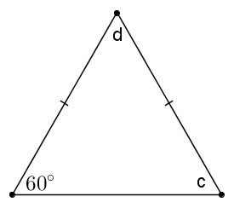

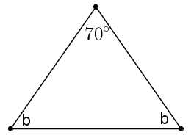

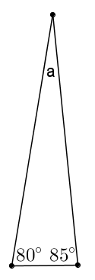

1. 2. 3.

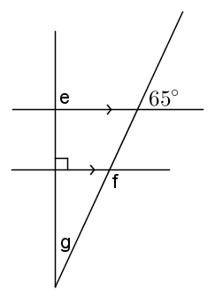

4. 5.

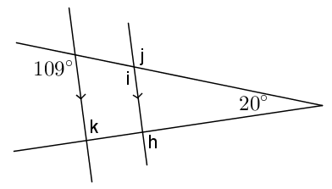

1. Construct the following:

1. Construct a triangle whose sides are 5 cm, 8 cm, and 10 cm long.

2. Construct ∆PQR such that PQ = 5 cm, QR = 8 cm, and m∠Q = 60º.

3. Construct ∆WXY such that WX = 8 cm, m∠W = 15º, and m∠X = 60º.

1. Construct 4 different scalene triangles.
2. In the first triangle, construct all the perpendicular bisectors of the sides.
3. In the second triangle, construct all the angle bisectors.
4. In the third triangle, construct all the altitudes.
5. In the fourth triangle, construct a line passing through a vertex and parallel to the opposite side of the chosen vertex.

**III. Question to ponder:**

Try to construct a triangle whose sides are 4 cm, 6 cm and 11 cm.

What did you observe? Could you explain why?

**IV. Discuss the following properties of a triangle:**

1. The perpendicular bisectors of the sides of a triangle are concurrent at a point. This point is called the **circumcenter** of the given triangle.

2. The medians of a triangle are concurrent at a point. This point is called the **centroid** of the given triangle.

3. The interior angle bisectors of a triangle are concurrent at a point. This point is called the **incenter** of the given triangle.

4. The altitudes of a triangle are concurrent at a point. This point is called the **orthocenter** of the given triangle.

**V. Summary**

In this lesson, we learned about triangles, its parts and its properties. The construction is used to illustrate some properties of a triangle involving the perpendicular bisectors of its sides, medians, bisectors of its interior angles and its altitudes.

**Lesson 35: Quadrilaterals**

**Prerequisite Concepts:** Polygons

**About the Lesson:**

This lesson is about the quadrilateral, its classifications and properties.

**Objectives:**

In this lesson, you are expected to:

1. Classify quadrilaterals

2. State the different properties of parallelogram.

**I. Lesson Proper**

**A. Learning about quadrilaterals**

A **quadrilateral** is a polygon with four sides.

**Some special quadrilaterals**

**Trapezoid** is a quadrilateral with exactly one pair of opposite sides parallel to each other. The parallel sides are called the **bases**, while the non-parallel sides are called the **legs**.

If the legs of a trapezoid are congruent (that is, equal in length), then the trapezoid is an **isosceles trapezoid**. Consequently, the base angles are congruent, and the remaining two angles are also congruent.

**Parallelogram** is a quadrilateral with two pairs of opposite sides parallel to each other.

**Exercise 25. Angles in Quadrilateral**

Find the angles marked with letters. (Note: Figures are not drawn to scales.)

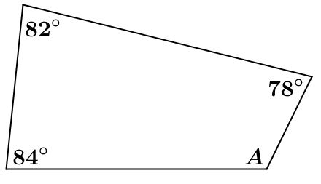

1. 6.

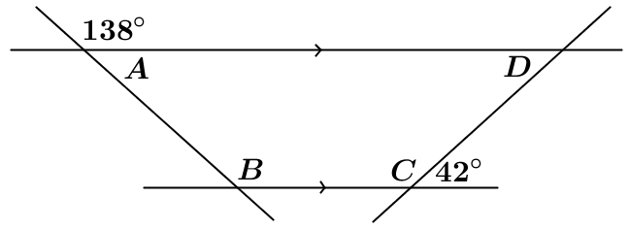

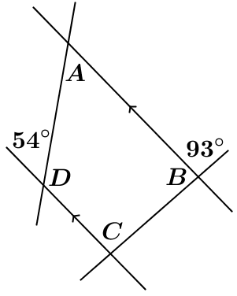

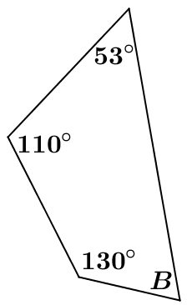

2. 7.

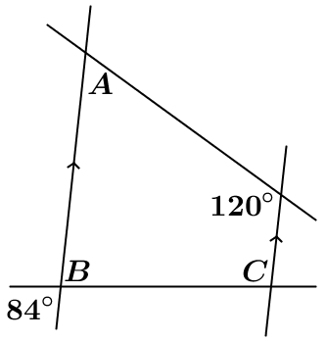

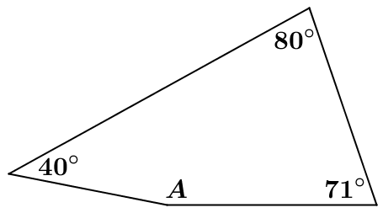

3. 8.

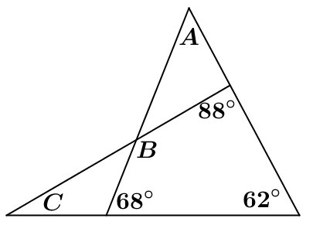

4. 9.

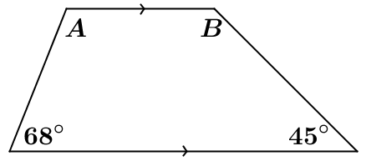

5.

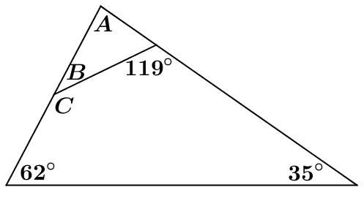

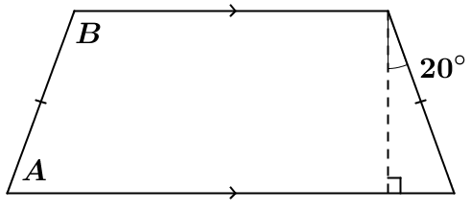

10.

**Activity 26**

**Vertices of a Parallelogram**

Using a graphing paper, plot the three given points. Then find the three possible points for the fourth vertex so that the figure formed is a parallelogram. Sketch the figure.

|  |  |
| --- | --- |
| **Given vertices** | **Possible fourth vertex** |
| A (2, 3), B (2, -3), C (4, 2) |  |
| E (-8, 3), F (-2, 5), G (-4, 1) |  |
| H (-3, 7), I (-6, 5), J (-1, 4) |  |
| K (6, 3), L (7, 5), M (2, 6) |  |
| N (6, -3), O (2, -4), P (5, -7) |  |

**Activity 27**

Materials: Pair of scissors, ruler, cardboards or papers

Procedures:

1. Prepare five models of parallelograms. (Or use the attached sketch of parallelograms.)

Name the parallelogram as ABCD.

1. For the first parallelogram: cut the parallelogram into two so that you can compare ∠A and ∠C; ∠B and ∠D. What do you observe?

**Opposite angles of a parallelogram are** _______________________.

1. For the second parallelogram: cut the angles and arrange any two consecutive angles about a point. What do you observe about the sum of any two consecutive angles of a parallelogram?

**Consecutive angles of a parallelogram are** ____________________.

1. For the third parallelogram: cut the figure along the diagonal AC. Compare the two triangles formed. Can they be coincided with each other?

For the fourth parallelogram: cut the figure along the diagonal BD.

Compare the two triangles formed. Can they be coincided with each other?

In both parallelograms, what do you observe about the triangles formed by the diagonals?

**Diagonals of a parallelogram divide the parallelogram into** ___________.

1. For the fifth parallelogram: cut the figure along the two diagonals. Then compare the partitioned diagonals. How did one diagonal divide the other diagonal?

**Diagonals of a parallelogram __**_______________________.

**Models for Activity 27**

D

C

B

A

D

C

B

A

D

C

B

A

D

C

B

A

D

C

B

A

D

C

B

A

D

C

B

A

D

C

B

A

**Special Properties of Rectangle, Square, Rhombus**

Materials: two sets of models of rectangles, squares, rhombus. Name each as ABCD.

(see attached sheet for the models)

Procedure:

1. Cut the rectangle along the diagonal AC. What type/s of triangle(s) is/are formed?
2. Cut the rhombus along the diagonal AC. What type/s of triangle(s) is/are formed?
3. Cut the square along the diagonal AC. What type/s of triangle(s) is/are formed?

**In which parallelogram does the diagonal divide the parallelogram into two congruent right triangles?**

1. In each figure, draw diagonals AC and BD and let the intersection be point O. In each figure, measure the lengths of the diagonals.

**In which parallelogram are the diagonals congruent?**

1. In each figure, draw diagonals AC and BD and let the intersection be point O. Then measure ∠AOD, ∠DOC, ∠COB, ∠BOA. What do you observe?

**In which parallelogram are the diagonals perpendicular?**

1. From the results of # 4-5, complete the statements below:

**Diagonals of a rhombus are _____________________.**

**Diagonals of a rectangle are _____________________.**

**Diagonals of a square are _______________________.**

**Models for Activity 28**

A B

D

C

A B

D

C

A B

D

C

A B

D

C

A B

D

C

A B

D

C

A B

D

C

A B

D

C

D

C

B

A

D

C

B

A

D

C

B

A

D

C

B

A

**Discussion:**

Properties of a parallelogram:

Opposite angles of a parallelogram are congruent.

Consecutive angles of a parallelogram are supplementary.

Diagonals of a parallelogram divide the parallelogram into two congruent triangles.

Diagonals of a parallelogram bisect each other.

A diagonal of a rectangle divides the rectangle into two congruent right triangles.

A diagonal of a square divides the square into two congruent isosceles right triangles.

Diagonals of a rectangle are congruent.

Diagonals of a rhombus are perpendicular.

Diagonals of a square are both congruent and perpendicular.

**Summary**

In this lesson, we learned about quadrilaterals and the different types of quadrilaterals. We also learned about parallelogram and its properties.

**Lesson 36: Circles**

**Prerequisite Concepts:** Distance, angle measures

**About the Lesson:**

Students have been introduced to circles as early as Grade 1, and they may easily recognize circles from a drawing, even without knowing how points on the circle are defined. This lesson extends students’ visual understanding of circles by introducing them to its mathematical definition. Definitions of terms related to the circle also developed.

**Objectives:**

In this lesson; you are expected to:

1. Define a circle and its parts.

2. Apply the definition to solve problems.

**Lesson Proper:**

**A. Circles**

**I. Activity**

Draw a point somewhere in the middle of a sheet of paper. Now, using a ruler, mark 20 other points that are 5 cm from the first point. Compare your work with that of your seatmates. What shape do you recognize?

You can probably recognize circles even when you were young. When you hear the word circle, round shapes may come to your mind. Now, we will learn how circles are shaped this way. In the activity above, you saw that points that points that are the same distance from a fixed point yields a round shape.

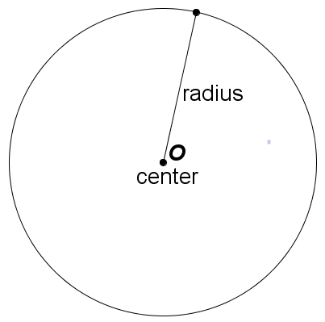

**Definitions:** A **circle** is the set of all points that are the same distance from a fixed point. This fixed point is called the **center** of the circle. A segment drawn from any point on the circle to the center is called a **radius.**

**Note**: A circle is named by its center. The circle at the right is called Circle *O*.

**II. Questions to Ponder**

1. Why do all radii (plural of radius) of a circle have the same length?

2. Which the following figures are circles?

  

3. Your grandfather told you that when he was young, he and his playmates buried some old coins under the ground, thinking that these coins will be valuable after several years. He also remembered that these coins were buried exactly 4 kilometers from Tree A (see map) and 5 kilometers from Tree B. Where could the coins possibly be located?

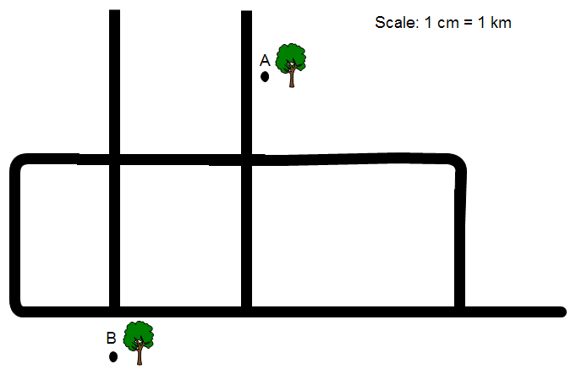

**B. Terms Related to Circles**

**I. Activity**

|  |  |
| --- | --- |
| On Circle O, segments *AD*, *BF*, *CG*, and *HE* were constructed so that their endpoints are points on the circle. Measure each segment, and determine which of these segments is the longest. | Find the measure of ∠*APB* below. |

The activity above introduced you to other parts of a circle.

A **chord** is a segment that connects any two points of a circle. *AD*, *BF*, *CG*, and *HE* are chords of Circle *O*.

A **diameter** is a chord that passes through the center of a circle. *BF* is a diameter of Circle *O*. It is the longest chord of a circle and it is twice the length of a circle’s radius.

A **central angle** is an angle whose vertex is on the circle’s center, and whose sides intersect the circle at two points. ∠*APB* is a central angle of Circle *P*.

An **arc** is a portion of a circle determined by a central angle. Arc *AB* is an arc of Circle *P*.

**II. Points to Ponder**

1. Determine whether each statement is true or false.

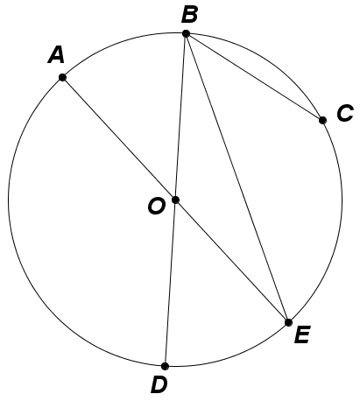a. Two radii always have the same length.

b. Two chords always have the same length.

c. All chords are diameters.

d. All diameters are chords.

e. All chords intersect at one point.

f. A radius is not a chord.

g. All diameters intersect at one point.

2. On Circle *O*,

a. name each radius.

b. name each diameter.

c. name each chord.

d. name each central angle.

e. name the arcs subtended by the central angles in (d).

3. Using a compass, draw a circle whose radius is 5 cm. Then draw the following objects. Write “impossible” if the object cannot be drawn.

a. One chord measuring 2 cm.

b. One chord measuring 10 cm.

c. One chord measuring 12 cm.

d. Three radii measuring 5 cm.

e. One central angle measuring 90°.

f. One central angle measuring 135°.

g. One arc subtended by an angle that measures 35°.

h. Three adjacent central angles, each measuring 10.