7

Learner’s Material

Module 5

This instructional material was collaboratively developed and reviewed by educators from public and private schools, colleges, and/or universities. We encourage teachers and other education stakeholders to email their feedback, comments, and recommendations to the Department of Education at action@deped.gov.ph.

We value your feedback and recommendations.

Department of Education
Republic of the Philippines

Mathematics – Grade 7
Learner’s Material
First Edition, 2013
ISBN: 978-971-9990-60-4

Republic Act 8293, section 176 states that: No copyright shall subsist in any work of the Government of the Philippines. However, prior approval of the government agency or office wherein the work is created shall be necessary for exploitation of such work for profit. Such agency or office may, among other things, impose as a condition the payment of royalties.

Borrowed materials (i.e., songs, stories, poems, pictures, photos, brand names, trademarks, etc.) included in this book are owned by their respective copyright holders. Every effort has been exerted to locate and seek permission to use these materials from their respective copyright owners. The publisher and authors do not represent nor claim ownership over them.

Published by the Department of Education
Secretary: Br. Armin A. Luistro FSC
Undersecretary: Yolanda S. Quijano, Ph.D.
Assistant Secretary: Elena R. Ruiz, Ph.D.
Development Team of the Learner’s Material

Consultant: Ian June L. Garces, Ph.D.

Authors: Elizabeth R. Aseron, Angelo D. Armas, Allan M. Canonigo, Ms. Jasmin T. Dullete, Flordeliza F. Francisco, Ph.D., Ian June L. Garces, Ph.D., Eugenia V. Guerra, Phoebe V. Guerra, Almira D. Lacsina, Rhett Anthony C. Latonio, Lambert G. Quesada, Ma. Christy R. Reyes, Rechilda P. Villame, Debbie Marie B. Verzosa, Ph.D., and Catherine P. Vistro-Yu, Ph.D.

Editor: Catherine P. Vistro-Yu, Ph.D.

Reviewers: Melvin M. Callanta, Sonia Javier, and Corazon Lomibao

Printed in the Philippines by ____________

Department of Education-Instructional Materials Council Secretariat (DepEd-IMCS)

Office Address: 2nd Floor Dorm G, PSC Complex
Meralco Avenue, Pasig City
Philippines 1600
Telefax: (02) 634-1054, 634-1072
E-mail Address: imcsetd@yahoo.com

Table of Contents

Statistics

Lesson 37: | Introduction to Statistics ………………………………. | 233
Lesson 38: | Organizing and Presenting Data ……………………... | 235
Lesson 39: | Organizing and Presenting Data Using Frequency Table and Histogram …………………………………... | 241
Lesson 40: | Averages: Mean, Median, and Mode ………………… | 245
Lesson 41: | Analyzing, Interpreting, and Drawing Conclusions from Graphics and Tabular Presentations …………... | 248

Lesson 37: Introduction to Statistics

Prerequisite Concepts: Measurement concepts, length measurements, measurement units

About the Lesson:
This is an introductory lesson to basic concepts, uses, and importance of Statistics. The first lesson allows you to experience systematic gathering and organizing data. This makes use of your knowledge of arranging numbers according to some considerations, like arranging numbers in descending or ascending order.

Objective:
In this lesson, you are expected to:
1. Collect or gather statistical data and organize the data in a frequency table according to some systematic consideration;
2. Explain the basic concepts, uses and importance of Statistics; and
3. Pose questions and problems that may be answered using Statistics.

Lesson Proper:

I. Activity
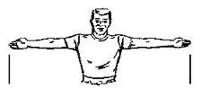
Measuring the arm span: Stretch out both arms and measure the length from the tip of a middle finger to the tip of the other middle finger.

http://www.gnbco.com/bow_length.php

Do you think students in this class have different arm spans? How many in this class have the same arm spans? What is the most common measure of arm spans? To answer these questions, you will to do the following:

Instructions:
1. Using a tape measure or a meter stick, measure your individual arm span. Use the centimeter (cm) unit of length. Round off measures to the nearest cm.
2. On the board, write your measures individually.

Questions:
1. What do these numbers represent?
2. Can we get clear and precise information immediately as we look at these numbers?
3. How can we make these numbers meaningful for anyone who does not know about the description of these numbers?

II. Activity
Based on the previous activity, after listing all your measures on the board, group yourselves in to groups of 5 to 8 members. Sort out the raw data and present it in a way you think would be a good presentation. After 10 to 15 minutes, present your output.

III. Questions/Points to Ponder
1. In our daily activities, we encounter a lot of sorting and organizing objects, data, or things like what you just did. These are just few of the activities of doing Statistics.
a. What are some of the few activities that you did in the previous activity?
b. What is Statistics?
2. Give some examples of activities which you think Statistics is involved.
3. List down some problems or questions that can be answered using Statistics.

IV. Exercises
Make a survey in your community or in school to find out how far students travel to come to school. Make the best estimate using kilometers. Ask at least 40 students and present your data using different methods.

V. Summary
In this lesson, you discussed different ways of presenting data in an organized manner. You were also introduced to a new area of mathematics called Statistics. You discussed the different activities involved in learning Statistics.

Lesson 38: Organizing and Presenting Data

Prerequisite Concepts: Ratio and proportion, measurement concepts

About the Lesson:
This lesson allows you to explore different ways of organizing and presenting data such as using tables, graphs or charts. Presenting data using graphs or charts such as frequency histogram, bar graphs, line graphs and pie charts or circle graphs will be studied. This will help you realize when to use such kind of graph and what information each of these types can provide.

Objective:
In this lesson, you are expected to:
- Organize data in a frequency table
- Use appropriate graphs to represent data.
Lesson Proper:

I. Activity
Consider the following charts and graphs and answer the questions that follow:

1. What information can we get from each of the above charts or graphs? Discuss each chart or graph.
2. Do they present the same information?
2. Describe each of the charts/graphs. What do you think are some uses of each of the charts or graphs?

II. Discussion

A histogram is a graphical representation showing a visual impression of the distribution of data. A histogram consists of tabular frequencies, shown as adjacent rectangles, erected over intervals. The height of a rectangle is also equal to the frequency.

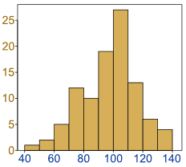
http://www.mathsisfun.com/data/histograms.html

A pie chart is a circle divided into sectors proportional to the frequencies. It shows how a part of something relates to the whole. It is important to define what the whole represents.

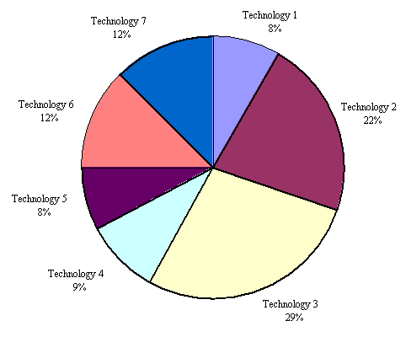
http://hwachongilp.wikispaces.com/6.+How+to+interpret+pie+charts+

A bar graph is like a histogram except that its bars are separated. This uses parallel bars, either horizontal or vertical, to represent counts for several categories. One bar is used for each category with the length of the bar representing the count for that one category.
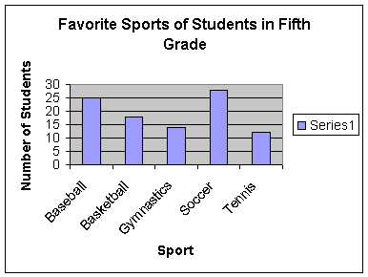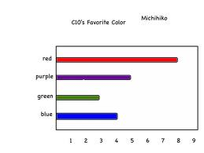
http://www.k12.hi.us/~gkolbeck/website/grade2.html

A line graph shows trends in data clearly. This displays data which are collected over a period of time to show how the data change at regular intervals.

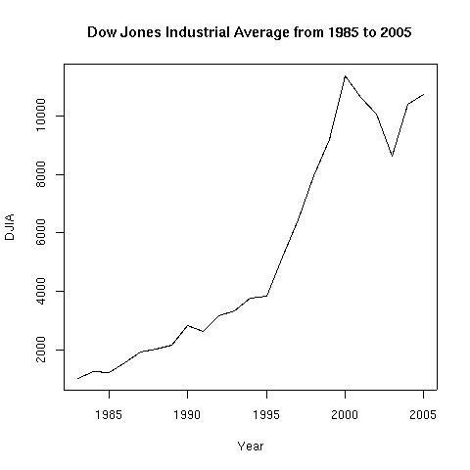
http://hwachongilp.wikispaces.com/7.+How+to+interpret+line+graphs

III. Activity

- Organize the following data and present using appropriate graph or chart. Explain why you are using such graph/chart in presenting your data.

  - The data below shows the population [in thousands] of a certain city.
Year | 1975 | 1980 | 1985 | 1990 | 1995 | 2000 | 2005 | 2010
Population in thousand | 65 | 78 | 80 | 81 | 82 | 86 | 90 | 120

  - The following data indicates the scores of 30 students who took the qualifying examination for mathematics challenge.
35, 60, 45, 56, 54, 20, 65, 80, 70, 34, 32
90, 95, 70, 24, 11, 70, 65, 70, 45, 32, 70
45, 55, 76, 77, 16, 92, 88, 86, 78, 54, 19

2. What is your story?

Work individually. After 10 minutes, share your answer to the person
next to you.

The bar chart below does not have a title and other important information is missing:
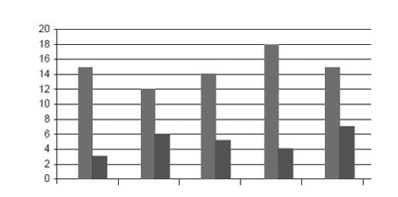
Use your imagination and knowledge of charts to help make sense of the above chart. Think of a suitable title that explains what the bar chart is all about. Provide all the needed information and labels to complete the graph.

IV. Questions to Ponder
- What are some of the different ways of presenting data?
- Describe the information that can be obtained from a data presented using
Bar Graph, Pie Chart, Line Graph, and Histogram

V. Exercises
1. Organize and present the following data using an appropriate chart or graph:

- An informal survey of 130 youth voters shows their top pick for senator:
Loren Legarda – 68
Chiz Escudero – 31
Bam Aquino – 13
Risa Baraquel – 10
Sonny Angara – 8

- Mr. Palanca recorded his weight every end of the month in the year 2012.
January 31 – 175 lbs July 31 – 163 lbs
February 29 – 176 lbs August 31 – 165 lbs
March 31 – 169 lbs September 30 – 161 lbs
April 30 – 169 lbs October 31 – 158 lbs
May 31 – 170 lbs November 30 – 155 lbs
June 30 – 165 lbs December 31 – 153 lbs

- Mrs. Bernardo tallied the Second Quarter Math grades of all 200 Grade 7 students in Lara’s school as follows:
96 – 100 23 students
90 – 95 45 students
86 – 89 55 students
81 – 85 30 students
78 – 80 26 students
75 – 77 10 students
70 – 75 11 students

2. Go to your school EMIS (Educational Management Information System) office and ask permission from the personnel at the principal’s office to guide you where the graphs/charts of the Performance Indicators of the school for the past 2 school years.
a. What are the performance indicators that you see?
b. What information can be obtained from the charts or graphs?
c. What is the significance of those charts or graphs?
d. Why is it important to put the data in graphs or in charts?

VI. Summary
In this lesson, you learned about the different ways of organizing and presenting data. These are histograms, pie charts, bar graphs and line graphs. You also learned which type of chart or graph suits a particular type of data to present.

Lesson 39: Organizing and Presenting Data Using Frequency Table and Histogram

Prerequisite Concepts: Sorting and Presenting Data

About the Lesson:
This lesson focuses on the use of frequency tables and histograms as a way of organizing and presenting data.

Objective:
In this lesson, you are expected to:
- Sort and organize data using frequency table
- Present data using a histogram.

Lesson Proper:

I. Activity
The following is a list of shoe sizes of 35 boys.
7 5 4 4 6 5 4
8 5 5 4 3 5 6
5 3 6 3 2 8 5
6 6 7 4 7 4 5
4 4 2 5 5 6 4

- What information can you get from the above list?
- What does the list tell us?
- The list above does not tell us anything. So what do we do with the list?

II. Discussion
1. The Frequency Table

We construct a table with three columns as shown. The shoe sizes may be grouped as follows: 1 - 3, 3 - 5, 5 - 7, and 7 - 9. Then we refer to our list and go down each column and make a mark for each figure or number in the tally table. For boundary sizes, we can use the rule that we include the lower bound in the interval but not the upper bound. The first count is 2 (for sizes 1 and 2), so we put two strokes. The next count is 12 (for sizes 3 and 4), so we put 12 strokes, and so on.

Shoe Size | Tally | Frequency
1 - 3  3 - 5  5 - 7  7 - 9 | ||  |||| |||| ||  |||| |||| |||| |  |||| | 2  12  16  5
Total: |  | 35

After tallying, we count the tally marks in each row and put the number in the last column. This is now called the frequency table.
2. The Frequency Histogram

From the frequency table, we are going to construct a histogram. A histogram is "a representation of a frequency distribution by means of rectangles whose widths represent class intervals and whose areas are proportional to the corresponding frequencies."

  - What does the height of each of the rectangles tell us?
The height of each rectangle corresponds to the frequency of the shoe sizes within an interval.
  - What is the total area of all the rectangles?
The total area of the rectangles is equal to 35
  - What does the total area tell us?
The total area of the rectangles is the total frequency.

III. Activity
Given the set of data, construct a frequency table and a frequency histogram using intervals of width 5.
34 45 37 29 20
36 20 20 34 45
40 40 34 45 40
30 30 20 29 36

The lowest data value is 20 so we can use 6 intervals of width 5: 20 – 25, 25 – 30, 30 – 35, 35 – 40, 40 – 45, and 45 – 50.
Interval | Frequency
20 – 25 | 4
25 – 30 | 2
30 – 35 | 5
35 – 40 | 3
40 – 45 | 3
45 – 50 | 3
Total | 20

And here is the corresponding frequency histogram made by Excel:

Can you come up with a different set of intervals and frequency count? Suppose you used 4 or 5 intervals only? How will the histogram differ?

IV. Questions/Points to Ponder

The frequency of a particular data value is the number of times the data value occurs.

What is a frequency table?
A frequency table is a table that lists numerical data that have been grouped in intervals and the frequency of occurrence of the data.

How do you construct a frequency table?
A frequency table is constructed by arranging collected data values in ascending order of magnitude with their corresponding frequencies. The data values are then grouped in intervals (e.g. 0 - 5, 5 - 10). Following a rule for boundary values, frequency counts are noted for each interval.

We use the following steps to construct a frequency table:
Step 1: Construct a table with three columns. In the first column, write down all of the data values grouped in intervals.

Step 2: To complete the second column, go through the list of data values and place one tally mark at the appropriate place in the second column for every data value in the interval following a specified rule for counting boundary values. When the fifth tally is reached for a mark, draw a horizontal line through the first four tally marks as shown for 6 in the above frequency table. We continue this process until all data values in the list are tallied.

Step 3: Count the number of tally marks for each interval and write the count in the third column.

What is a frequency histogram?
A histogram is a vertical bar graph of a frequency distribution of data values grouped into intervals.

How do you construct a frequency histogram?

Step 1: Place the data intervals along the horizontal axis.

Step 2: Mark the frequency numbers on the vertical axis.

Step 3: Draw rectangles for each interval. The height of the rectangle is the frequency count for that interval.

V. Exercises
The following are test scores of Section 1. Construct a suitable frequency table and a frequency histogram. Use intervals of width 6.

14 15 30 19 10 18
26 30 10 15 15 28
10 30 34 40 20 43
20 30 10 22 36 36

VI. Summary
You learned how to construct frequency tables and a frequency histogram. A frequency table is a table that lists items and uses tally marks to record and show the number of times data values occur. A histogram is a vertical bar graph of a frequency distribution of data values grouped into intervals.

Lesson 40: Averages: Mean, Median, and Mode

Prerequisite Concepts: Sorting and Presenting Data

About the Lesson:
This is a lesson on computing for the values of Mean, Median, and Mode given a set of data. You will also describe data using the mean, median, and mode. Problem solving involving Mean, Median, and Mode is also included in this lesson.

Objective:
In this lesson, you are expected to:
1. Find the mean, median, and mode of a statistical data.
2. Solve problems involving mean, median, and mode.
3. Describe the data using information from the mean, median, and mode.

Lesson Proper:

I. Activity
The set of data shows a score of 35 students in their periodical test.

34 | 35 | 40 | 40 | 48 | 21 | 9
21 | 20 | 19 | 34 | 45 | 21 | 20
19 | 17 | 18 | 15 | 16 | 20 | 28
21 | 20 | 18 | 17 | 10 | 45 | 48
19 | 17 | 29 | 45 | 50 | 48 | 25

- What score is typical to the group of students? Why?
- What score frequently appears?
- What score appears to be in the middle? How many students fall below this score?

II. Discussion
1. The mean is commonly referred to as the average of all values. To compute for the mean, add all the scores and divide the sum by the number of scores. It is the easiest “average” to compute.
2. The most frequent score/s in the given set of data is called the mode. It is also an “average” score. A data set may have two modes (and hence the data set is called bimodal).
3. The median is also an “average” score. It is the middle score in the list after the scores are arranged in decreasing or increasing order. How do you get the median for an even number of scores in a set of data? What about for an odd number of scores?
III. Activity
- The following sets of data show the height [in centimeters] of two groups of boys playing basketball.
Group A: 135, 136, 140, 150, 134, 129, 126, 130
Group B: 167, 136, 119, 136, 160, 178, 126, 140

  - Compute for the mean.
  - What information can you get from these two values?

- The following sets of data show the weekly income [in peso] of ten selected households living in two different barangays in the town of Kananga.
Brgy. Kawayan: 150, 1500, 1700, 1800, 3000, 2100, 1700, 1500, 1750,
1200
Brgy. Montealegre: 1000, 1200, 1200, 1150, 1800, 1800, 1800, 2000,
1470, 8000

  - Compute for the mean and the median for each Barangay.
  - What information can we get from these values?
  - Why do you think the median is more appropriate than the mean?

IV. Questions/Points to Ponder

The mean is the score obtained if all the scores are “evened out”. For example, 5 boys have the following ages: 14, 12, 12, 15, and 12. If the ages are “evened out” (2 from 15 distributed to each of the 12 and 1 from 14 added to the other 12) then all 5 ages become 13. Thus, the mean age is 13. The mean is affected by extreme values.

The median is the middle score in the ordered list of the values. For example, in the case of the ages of the five boys, the ages may be arranged as: 15, 14, 12, 12, and 12. Hence, the median is 12, lower than the mean. The median is not affected by extreme values because its position in an ordered list stays the same.

The mode is the most common value. In the example, the mode is the age with the highest frequency count among the 5 boys and that is 12. The mode is useful if the interest is to know the most common value. For example, a company has give-away items for teens. To determine if the items are age-appropriate, the company might simply ask for the most common age in the group.

V. Exercises
1. Below are the mathematics grades of 30 Grade 7 students in the last quarter:

78 | 98 | 76 | 89 | 89 | 83
87 | 75 | 72 | 91 | 90 | 79
84 | 84 | 85 | 88 | 87 | 95
96 | 95 | 96 | 96 | 76 | 80
83 | 82 | 85 | 92 | 91 | 90

Compute for the mean, median and mode.

2. Mario took four examinations in a science class. His scores are 48, 65, 78, and 79. Which measure is more appropriate to use in order to determine how well Mario is performing in science?

3. The National Housing Authority publishes data on resale prices of houses in Metro Manila. Which of mean, median and mode is more appropriate to use? Explain your answer.

4. Solve the following problems:
a. The median for 10, 9, y, 12, and 6 is y. Find possible values of y, given that the values are whole numbers.
b. The mean of fifteen numbers is 30 and the mean of ten numbers is 25. What is the mean of all the twenty-five numbers?
c. Given the set of numbers N = {7, 9, 10, 14, 8, 16, 13}. When a number x is added to the set, the new mean is 12. Calculate the value of x.

VI. Summary
In this lesson, you learned about the three different “averages” of a set of numerical data: Mean, Median and Mode. The mean is the most commonly known average and is obtained by adding all the values and dividing the sum by the number of values. The median is the middle value in the ordered list of all values. The median is not affected by extreme values, unlike the mean. If there is an odd number of data values, the median is the middle value in the ordered list. If there is an even number of data values, the median is the mean of the two middle values in the ordered list. The mode is the value with the highest frequency count. It is useful in certain situations that simply ask for the most common value.

Lesson 41: Analyzing, Interpreting, and Drawing Conclusions from Graphics and Tabular Presentations

Prerequisite Concepts: Organizing data using charts, tables and graphs; Mean, Median and Mode

About the Lesson:
This lesson serves as a consolidation and practice of what you learned in the previous lessons. The problems will give you the opportunity to work in groups and discuss different solutions. You will also learn to justify your answers using data.

Objective:
In this lesson, you are expected to analyze, interpret accurately and draw
conclusions from graphics and tabular presentations of statistical data.

Lesson Proper:

I. Activity

Solve the following problems in groups or in pairs.

- Daria bought 3 colors of T-shirts from a department store. She paid an average of PhP 74.00 per shirt. The receipt is shown below where part of it was torn.

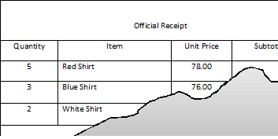

  - How much did she pay for each white shirt?
  - How much did she pay in all? How did you determine this?

- Samuel brought ten sachets of chocolate candies. He checked the sachets and found that they contain 12, 15, 16, 10, 15, 14, 12, 16, 15, and 12 candies.

  - According to the data, what is the mean number of candies per sachet?

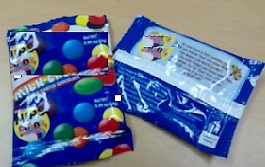 AVERAGE CONTENT: 14

  - The above information is written on each pack of candies. Why do you think this number is different from the answer to (a)?

- The Municipal Agriculturist of Kananga made a survey of fruit trees available in the orchard. He made a chart that shows the distribution of types of fruit trees planted.

- How do the number of Durian and Rambutan trees compare?
- What is the most common fruit tree?
- What fraction of the fruit trees is Santol?
- If there are 150 fruit trees altogether, how many are Mangosteen trees?

II. Activity

1. Mrs. Amodia, the School Librarian prepared a bar chart that shows the number of students who borrowed magazines in the library last week.

  - How many magazines were borrowed on Friday? How many students borrowed magazines on this day?
  - What is the mean number of magazines borrowed per day last week? How many students borrowed magazines in all of the five days?
  - On what day had the most number of students borrow magazines?
  - How many students borrowed magazines on Tuesday?

2. The pie chart below shows the memberships of the different clubs in Ormoc City National High School.

- What is the ratio of the number of students who are members of the Computer Club to that of the members of the Glee Club?
- What percentage of the students are members of the Drama Club?
- If there are a total 240 students, how many are members of the Mathematics Club?

III. Questions/Points to Ponder
By analyzing data from graphs, charts and tables carefully, you could derive important information that lead to well-justified answers or conclusions. Hence it is important for students what each type of data presentation emphasizes. Combine with that the understanding of the measures mean, median and mode and the information gets richer. This is the most important part of this lesson.

IV. Exercise
- From the local newspaper, cut out at least two different charts or graphs and write questions that will help your classmates interpret the graph or chart. Write down some implications that are important to you or to the community.

- Study the pie chart below that shows the kinds of books owned by a local library:

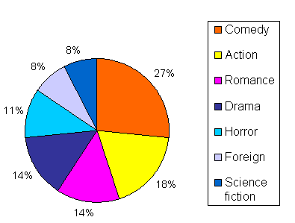
a. What type of book does the library have the most number of compared to any other type in its collection?
b. If there are 850 books in the collection, how many books are there of each type? What is the “average” number of books per type?
c. How many more Science Fiction books should be added to the collection
in order to match the Comedy Book collection? What percentage of the
collection is each type when this happens?

- USD to PHP Exchange Rates: (US Dollar to Philippine Peso) Charts and historical data
Last 10 working days
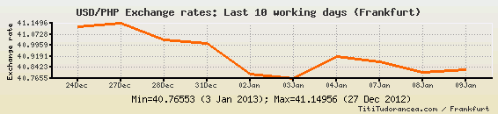

a. On what day was the peso strongest against the US dollar?
b. On what days did the peso appreciate against the US dollar?
c. Can you explain the scale on the vertical axis?
d. What is the “average” peso-dollar exchange rate from Dec 24 to Jan 9?

V. Summary
In this lesson, you learned to interpret information gathered from tables, charts and graphs. You also learned to analyze data by obtaining the measures mean, median and mode.

